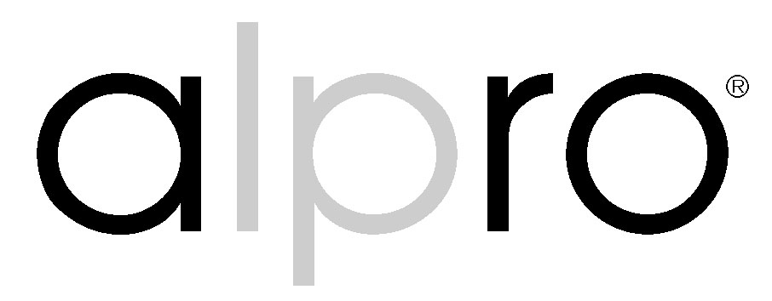

Why Purchase The New Alpro Strike Range?

The Alpro strike comes as a complete package. It includes both long and short faceplate options. 15, 25, 50 and 75mm extension lips are available as required and a full and easy to use fixing pack enclosed. In short a “one stop” strike package.

The strike range is fail safe/fail secure and has an easy function change, which can be effected in less than 30 seconds.

The AL 110 strike has a very shallow body depth of 35mm making it one of the smallest, if not the smallest strike bodies available. This is very “user friendly” to aluminium OEM’s as the shallow depth ensures it does not interfere with the glazing pockets in the aluminium section.

The Alpro range is 12/24v DC/AC (with RM1 rectifier) fail safe/fail secure allowing one strike to suit eight possible applications. Again allowing for one single purchase to suit all possible customer requirements.

There are cheaper alternatives available, but buying a cheaper strike up front is false economy. The money saved is lost when the product fails and needs to be replaced. There are also additional costs to be borne when this happens, such as travel and installation costs. There could also be the cost of lost property or an attack against an individual.

The Alpro strike range carries a 6 year warranty. Cheaper versions usually only carry a 12 month warranty.

At anytime during the 6 year warranty Alpro will replace it F.O.C. if the product fails.

The Alpro strike is manufactured from with a strong Zinc alloy body and stainless steel jaw. Stainless steel faceplates are supplied as standard.

Cheaper strikes are often manufactured from a lower quality material and often with a folded or screwed construction, thereby making them inherently weaker than an Alpro strike.

Cheaper strikes use cast jaws, not stainless steel ones like the Alpro strikes.

The Alpro strike is a compact product which reduces the need for larger cut outs in doors and frames (which could in turn weaken them), but maintains the security and integrity of the door set.

Cheaper strikes tend to use higher currents thereby producing more heat.

Alpro strikes are CE marked, cheaper ones are not.

The Alpro strike and all other associated products are supported by a nationwide external sales force, an internal sales force along with comprehensive technical back up and after sales

